Option 1: Pixelzone by GGBotNet

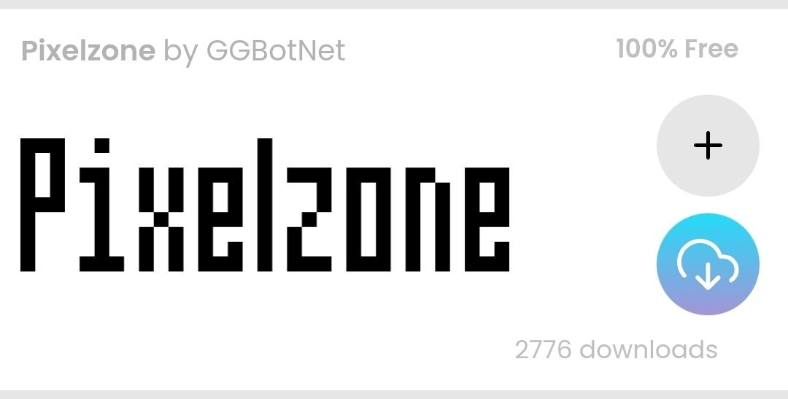

https://www.fontspace.com/category/pixel,game

Option 2: KoPub바탕체

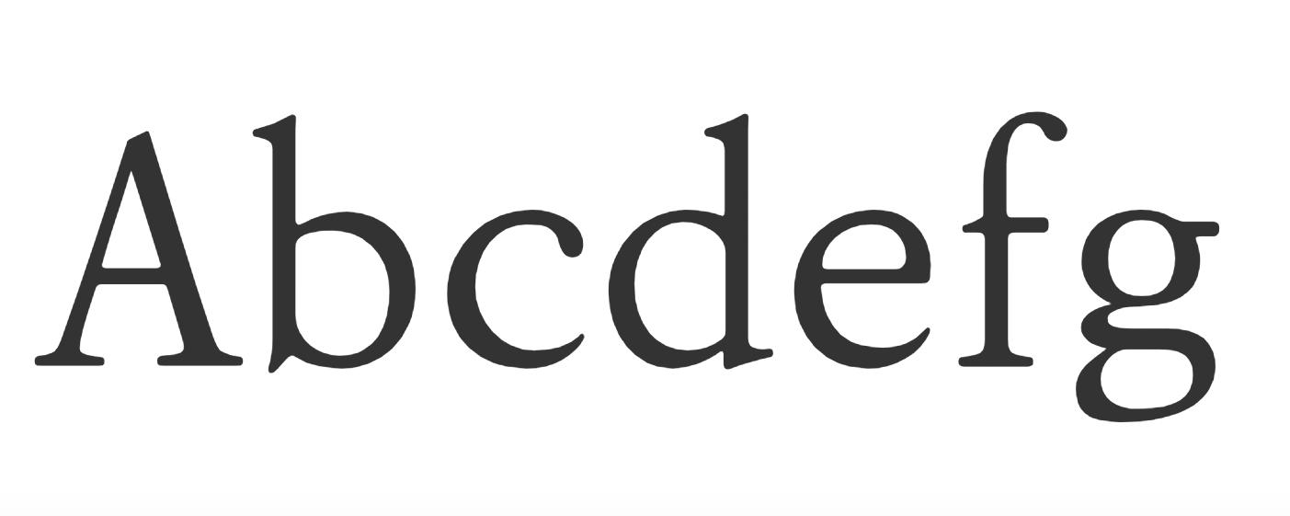
https://www.kopus.org/biz-electronic-font2-2/

Option 3:

